Creating the Initial Table for the Volunteer Database
CREATE TABLE volunteers (
volunteer_id INT AUTO_INCREMENT PRIMARY KEY,
first_name VARCHAR(50) NOT NULL,
last_name VARCHAR(50) NOT NULL,
street_address VARCHAR(100),
city VARCHAR(50),
state CHAR(2),
zip_code VARCHAR(10),
phone_number VARCHAR(20),
email VARCHAR(100)
);
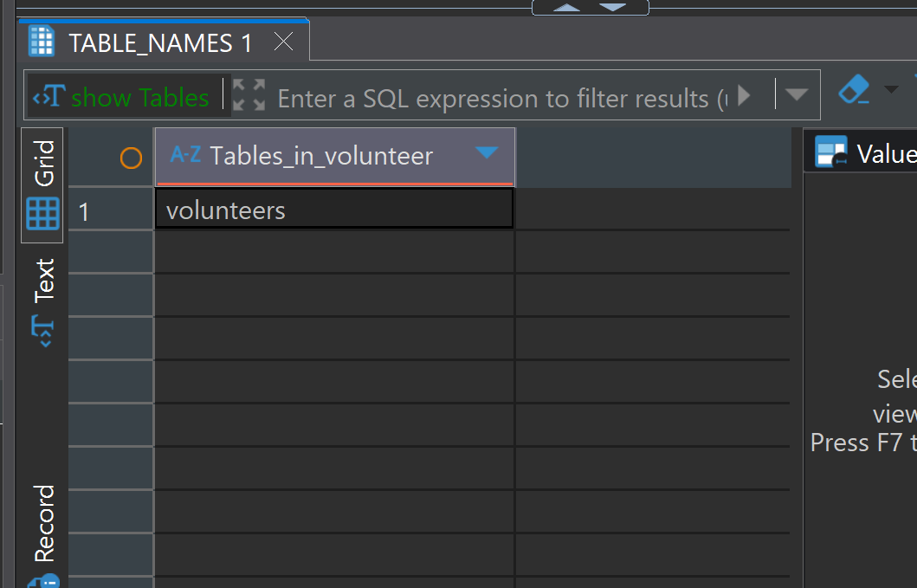
-Screenshot above: Volunteer table created successfully
INSERT INTO volunteers (
first_name, last_name, street_address, city, state, zip_code, phone_number, email
) VALUES (
'Emily', 'Johnson', '123 Maple St', 'Springfield', 'IL', '62704', '(217) 555-1234', 'emily.johnson@example.com'
);
INSERT INTO volunteers (
first_name, last_name, street_address, city, state, zip_code, phone_number, email
) VALUES (
'Marcus', 'Lee', '456 Oak Ave', 'Columbus', 'OH', '43215-1234', '(614) 555-5678', 'marcus.lee@example.com'
);
INSERT INTO volunteers (
first_name, last_name, street_address, city, state, zip_code, phone_number, email
) VALUES (
'Sarah', 'Nguyen', '789 Pine Blvd', 'Austin', 'TX', '73301', '(512) 555-9012', 'sarah.nguyen@example.com'
);
INSERT INTO volunteers (
first_name, last_name, street_address, city, state, zip_code, phone_number, email
) VALUES (
'David', 'Smith', '321 Birch Rd', 'Madison', 'WI', '53703', '(608) 555-3456', 'david.smith@example.com'
);
INSERT INTO volunteers (
first_name, last_name, street_address, city, state, zip_code, phone_number, email
) VALUES (
'Isabella', 'Martinez', '654 Cedar Ln', 'Tampa', 'FL', '33602', '(813) 555-7890', 'isabella.martinez@example.com'
);
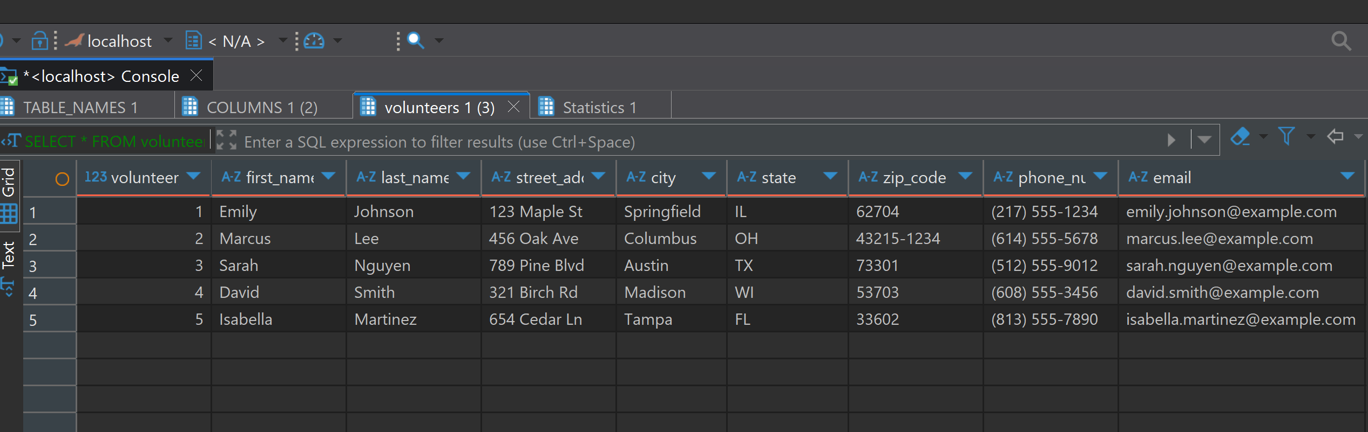
-Screenshot above: Results of data entered for the volunteer table which includes first and last name, volunteer identifier, street address, city, state, zip code, phone number and email of each volunteer.
Volunteers Database Design and Its Role in the DBLC and SDLC
Designing an efficient and secure database is a foundational step in managing organizational data. In this project, I created a volunteers table that stores essential information about each volunteer while balancing functionality and data integrity. This paper discusses the column choices, data types, and how these decisions align with the broader frameworks of the Database Life Cycle (DBLC) and the Systems Development Life Cycle (SDLC).
Database Table Design Choices
The volunteers table is designed to capture key attributes needed to manage volunteer records. Each volunteer is uniquely identified using an AUTO_INCREMENT integer column named volunteer_id. This ensures each record is assigned a unique identifier without relying on sensitive information like Social Security numbers, which present privacy concerns (Coronel & Morris, 2019).
The volunteer's name is split into first_name and last_name columns, each defined with a VARCHAR(50) data type. This separation supports flexible querying and alphabetical sorting by last name.
To support communications and logistics, mailing address information is stored across four fields: street_address, city, state, and zip_code. The state field uses CHAR(2) for U.S. postal abbreviations, while zip_code is defined as VARCHAR(10) to accommodate formats like "12345" and "12345-6789", since ZIP codes are not numeric and can include leading zeros and hyphens.
Contact fields include phone_number and email, both stored as VARCHAR types. Phone numbers often contain formatting characters like parentheses and dashes, so treating them as strings rather than integers prevents data loss or corruption. The email field also uses a VARCHAR(100) type to allow sufficient space for most email addresses.
Relation to DBLC and SDLC
The database design process fits within the Database Life Cycle (DBLC), which includes stages such as requirements analysis, database design, implementation, testing, and maintenance (Pratt & Last, 2020). This table reflects the implementation phase, built upon earlier requirements analysis and logical design. Populating the table with sample data represents part of the testing phase, ensuring that the schema supports realistic inputs.
In the broader Systems Development Life Cycle (SDLC), the database supports the larger system that may include volunteer tracking, scheduling, or communications modules. The SDLC stages—planning, analysis, design, implementation, and maintenance—encompass both application and database development. A well-structured volunteers table ensures that other system components can reliably interact with the database, thus promoting data integrity and application efficiency.
Conclusion
The design of the volunteers table illustrates careful planning to balance privacy, data usability, and structural efficiency. Each column and data type was chosen based on common data management practices and user needs. This design is not only a product of good database development but also a reflection of its integration into the broader DBLC and SDLC frameworks, ensuring scalability and reliability in long-term system use.

References
Coronel, C., & Morris, S. (2019). Database systems: Design, implementation, & management (13th ed.). Cengage Learning.
Pratt, P. J., & Last, M. Z. (2020). Concepts of database management (10th ed.). Cengage Learning.

